# DAD 220 Module Three Major Activity Template

## Overview

Complete these steps as you work through the directions for this activity. Replace the bracketed text with a screenshot and brief explanation where indicated. Each screenshot and its explanation should be sized to approximately one-quarter of the page with the description written below the screenshot. Review the Template Screenshot Example linked in the guidelines and rubric for this assignment to see how screenshots for your assignment should look.

## Create a Database

1. In your online integrated development environment (Codio), **create a database schema** called Quantigration RMA that can hold tables.
   1. List the database name on the screen.
   2. Provide the SQL commands you ran to successfully complete this step.

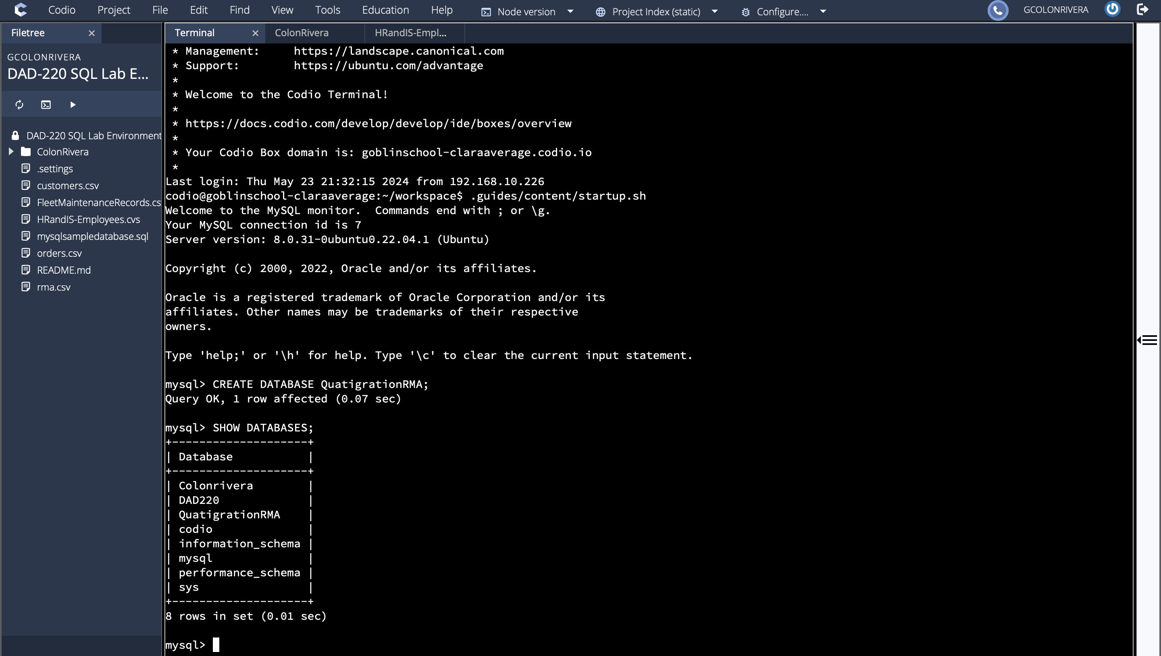

1. Connect to the Quantigration RMA schema. **Create** the following **tables with the appropriate attributes and keys** in the Quantigration RMA database using the Quantigration RMA Entity Relationship Diagram (ERD) as a reference:
   1. A table named **Customers** to store customer information with a primary key of Customer ID
      1. Provide the SQL commands you ran against MySQL to complete this successfully in your answer:

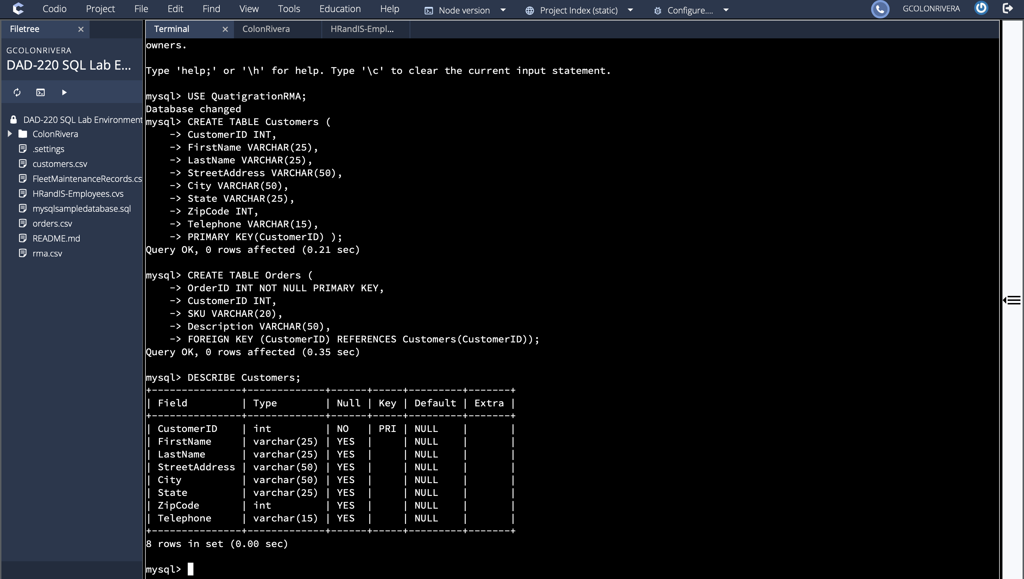

* 1. A table named **Orders** to store order information with a primary key of Order ID and foreign key of Customer ID
     1. Provide the SQL commands you ran against MySQL to successfully complete this step.

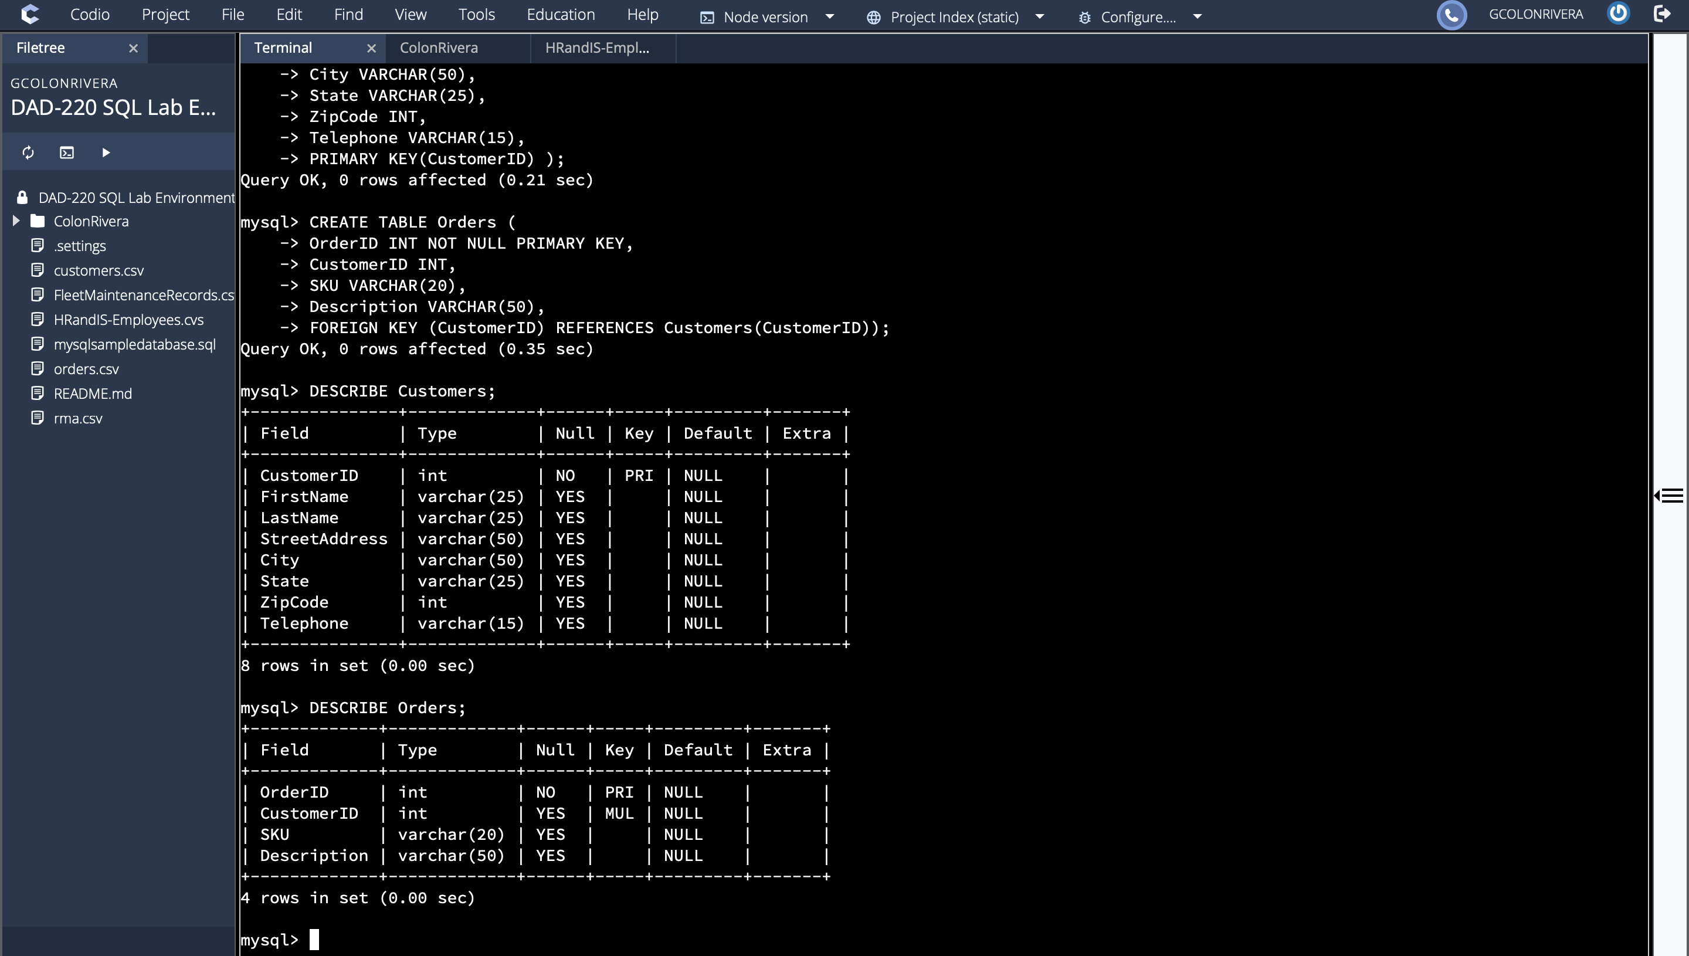

* 1. A table named **RMA** to store RMA information with a primary key of RMA ID and foreign key of Order ID
     1. Provide the SQL commands you ran against MySQL to successfully complete this step.

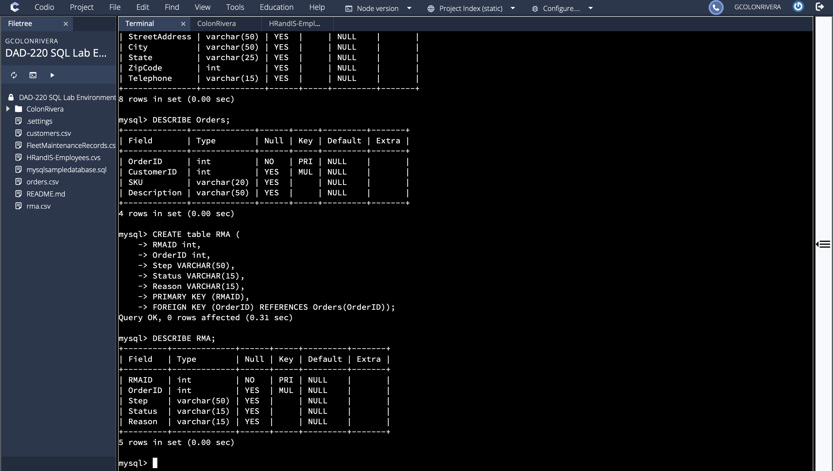

1. Manually **add 10 records** into the **Customers table**. For now, you can make up data. In a later assignment, you will use the CSV files provided to fill in all three tables.

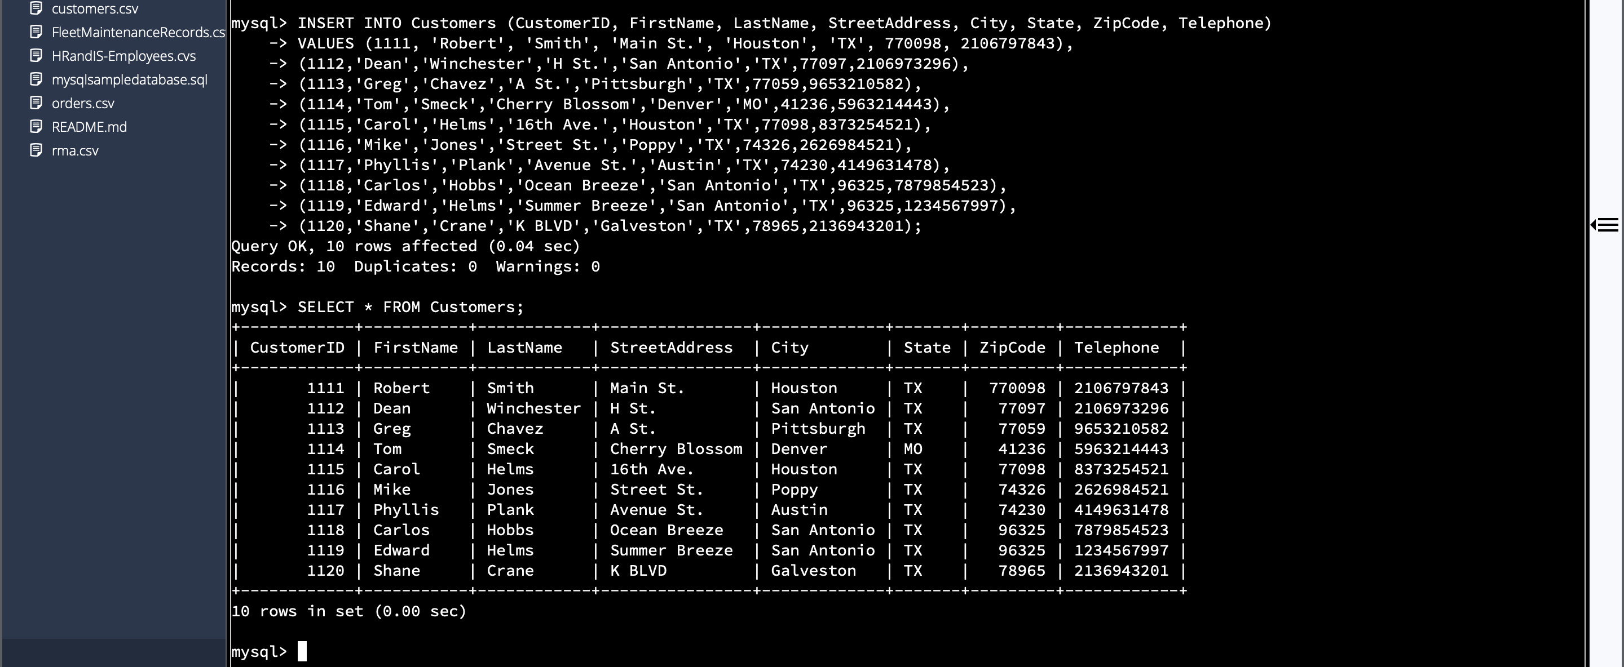

1. You’ve been asked to establish a database view called Collaborators based on the Customers table. **Create** the **Collaborators View** from theexisting Customers tableby using the SQL command belowto say "Collaborators". The view should show all instances of "Customer" renamed as "Collaborator". Execute the following statements and provide one or more supporting screenshots showing the database view.
   1. The following command is partially complete. Fill in the missing information in the brackets to complete then command and run it correctly:

CREATE VIEW Collaborator AS

SELECT CustomerID AS CollaboratorID

[Enter in the correct column names from the Customer table that you want to change in the Collaborator table]

FROM Customers;

* 1. DESCRIBE Collaborator;
  2. SELECT * FROM Collaborator LIMIT 5;

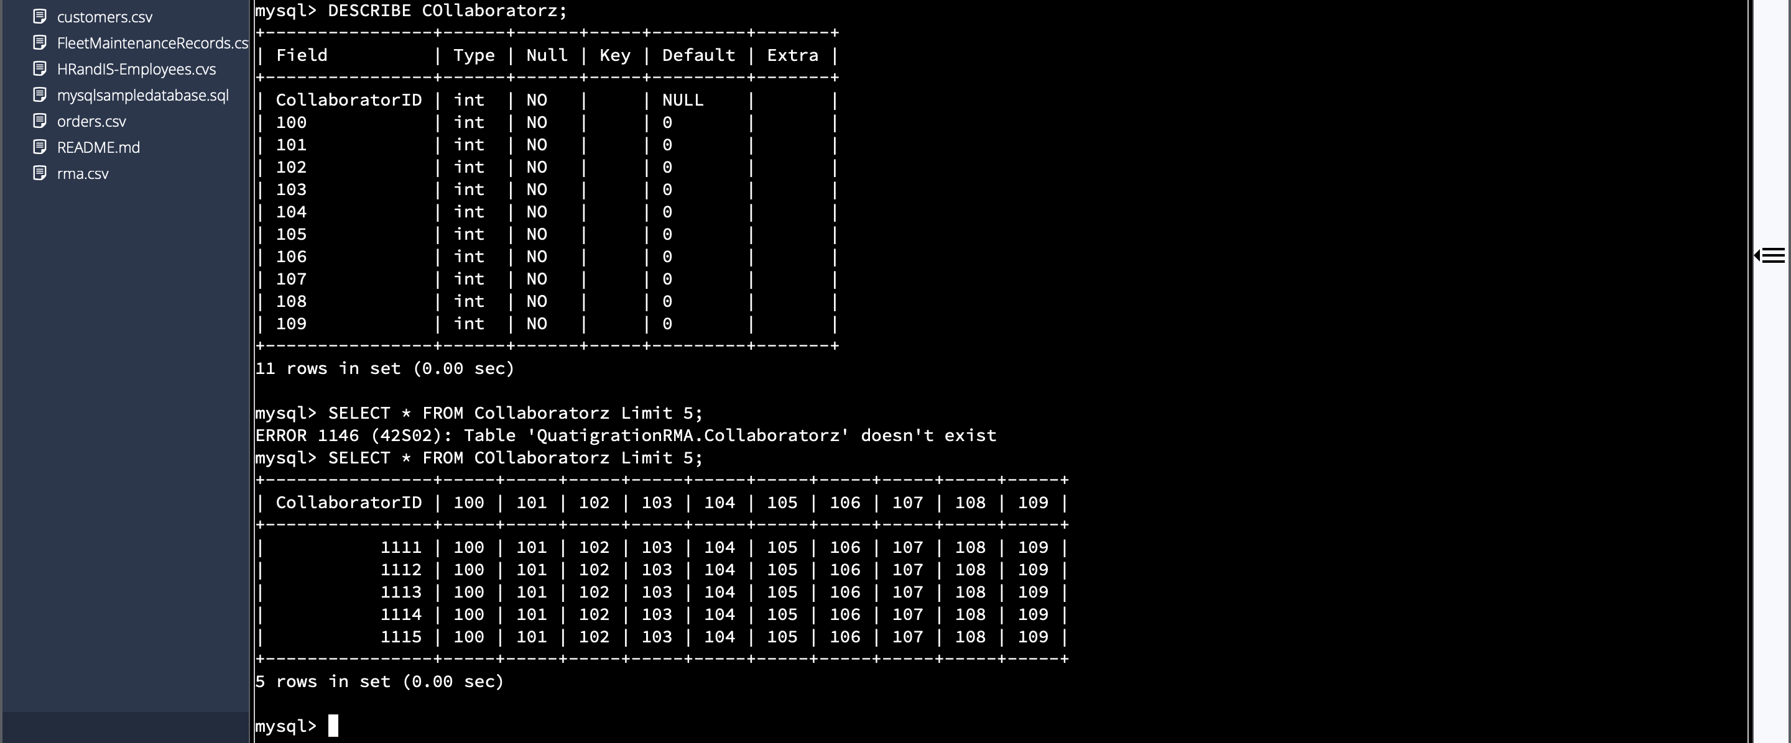

I struggled with the instructions that said "Collaborators"  It ended up adding extra items into the table. I had to use "COllaboratorz"to make a new table. However, I was able to import the customer ID and specified the data source as per the code provided above, and executed the code successfully to complete the task.